**Question 3.3 (Putting it first for ease of checking):**

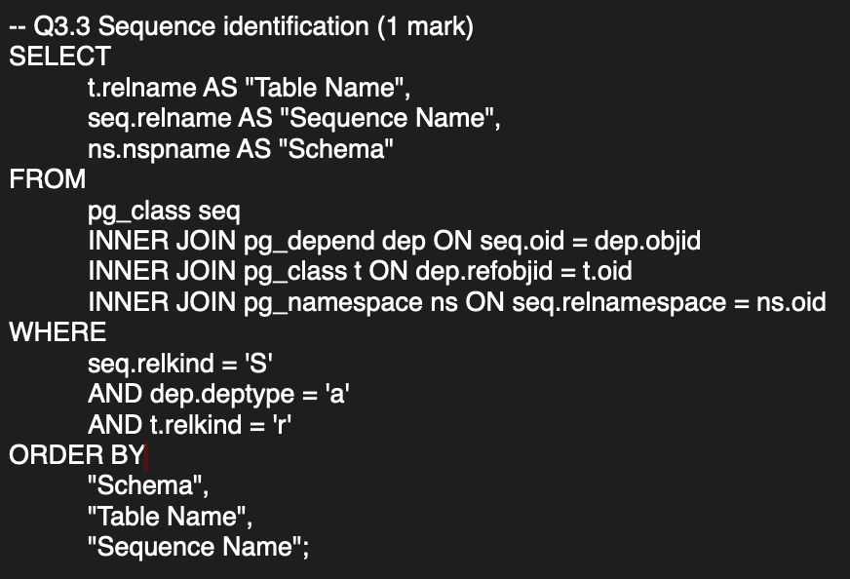

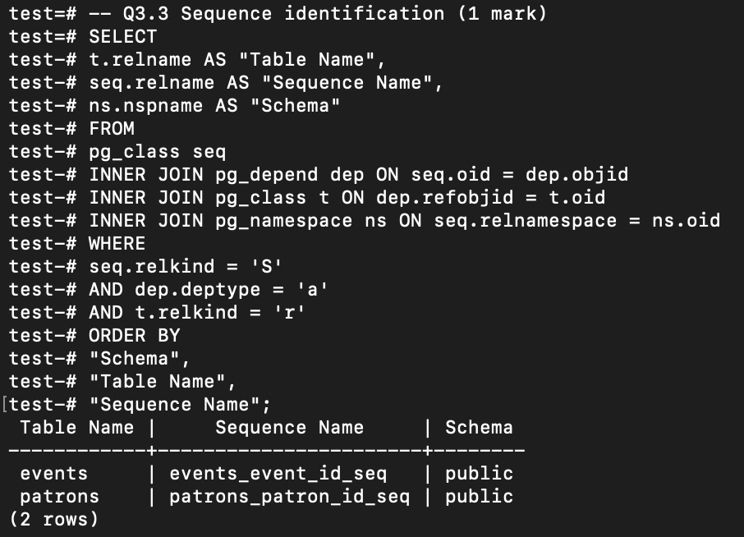

**Question 1:**

**Question 2.1:**

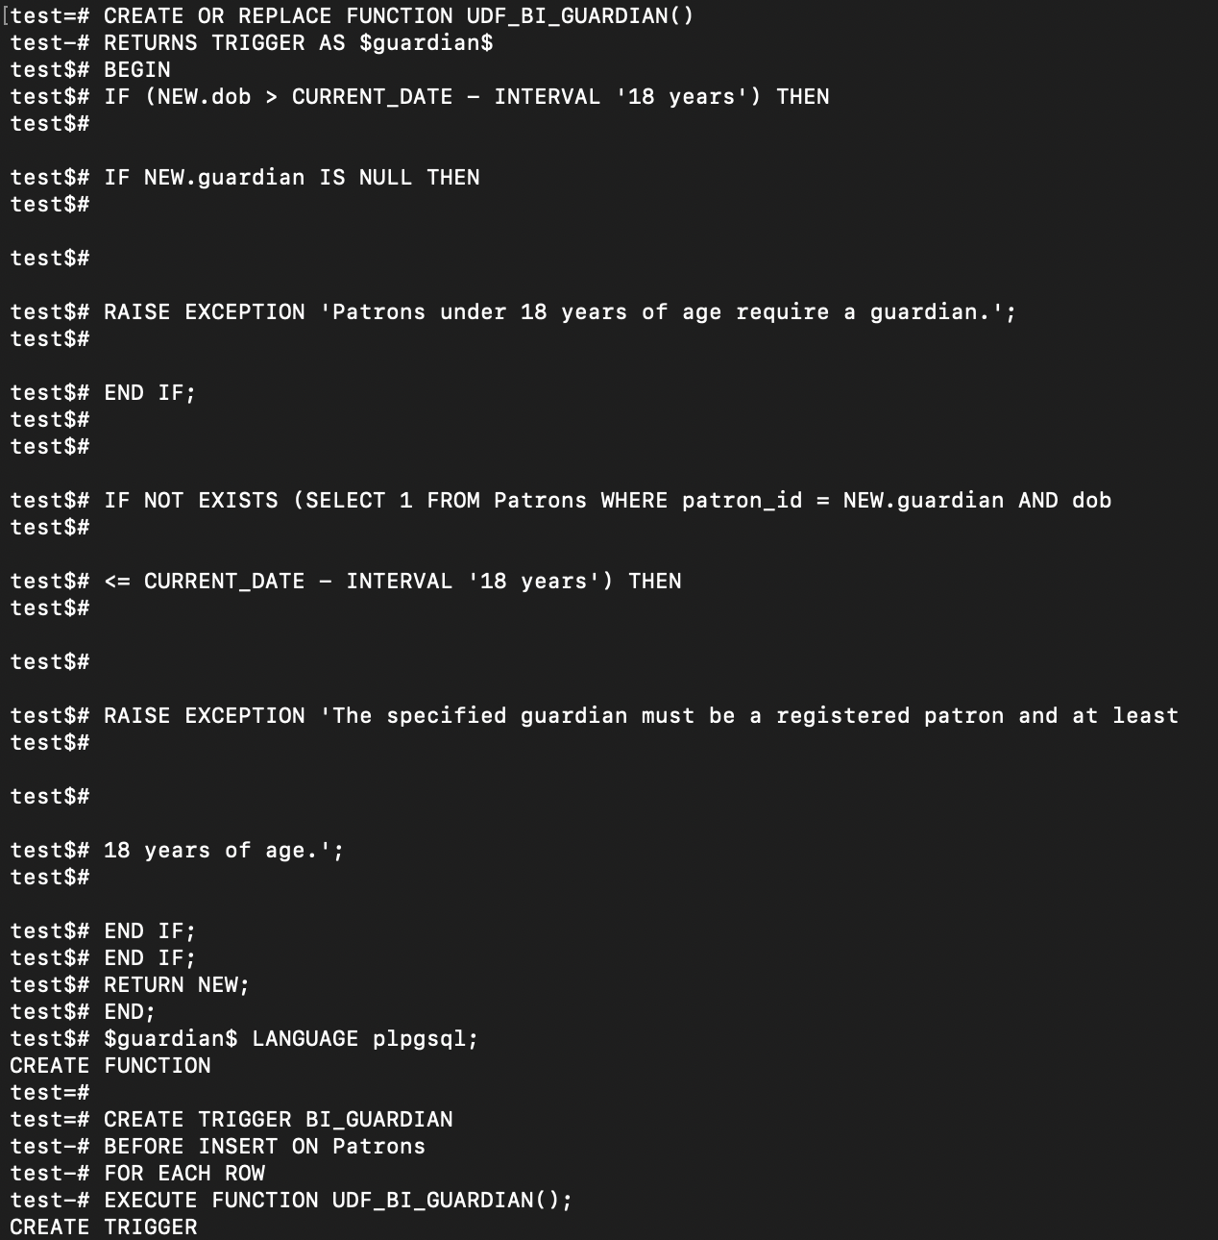

**Question 2.2:**

**Question 3.1:**

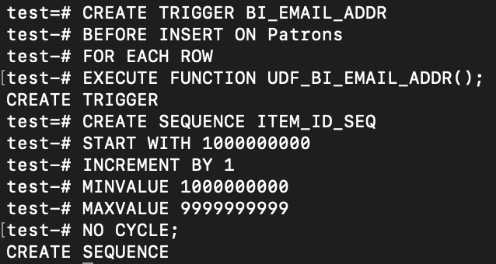

**Question 3.2:**

**Question 4.1:**

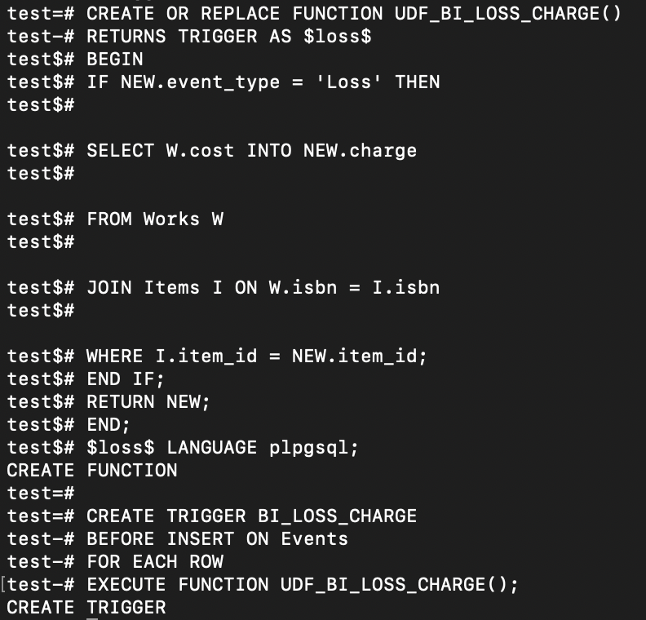

**Question 4.2:**

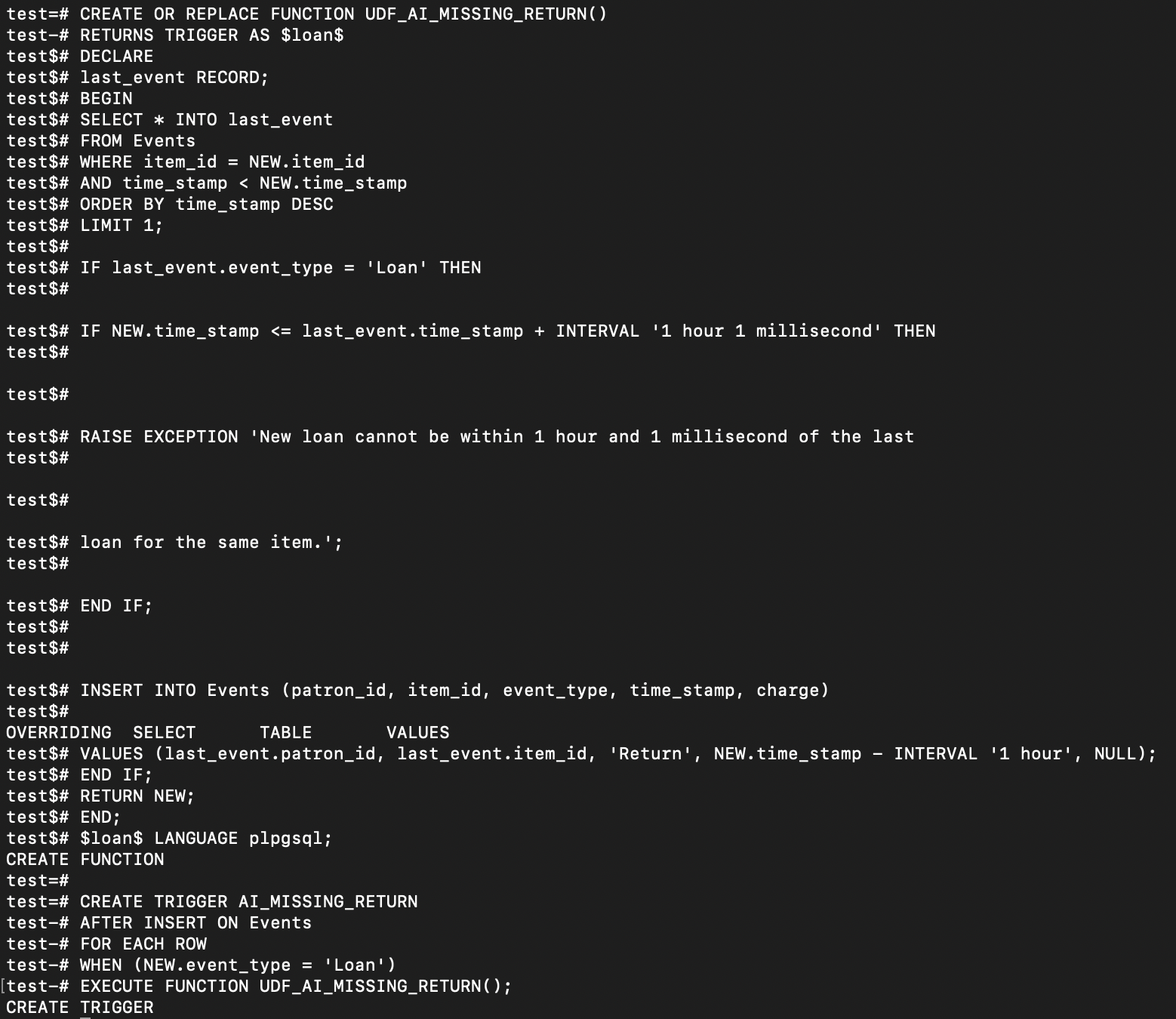

**Question 4.3:**

